Solutions

SWIFT for Corporates

Bank Readiness Programme

Version 4.3
This document describes the operational and commercial criteria a bank needs to meet in order to become certified for corporate access as well as the application process.

July 2017

Table of Contents
1. Introduction 3
1.1 Purpose of the document 3
1.2 Main principles 3
1.3 Entry Readiness Certification 4
1.4 Advanced Readiness Certification 4
1.5 Additional SWIFT capabilities 5
2. Mandatory operational criteria 6
2.1 Context: SCORE 6
2.2 Messaging 6
2.3 Testing capabilities 6
2.4 Documentation 7
2.5 Implementation support 7
3. Mandatory commercial criteria 7
3.1 Sales staff 7
3.2 Commercial documentation 8
4. Additional SWIFT capabilities 9
4.1 To be registered as SWIFT gpi member 9
4.2 SWIFT gpi payments (gCCT) – live 9
4.3 Correctly support MT 300 – Foreign Exchange Confirmation 9
4.4 Correctly support MT 320 – Fixed Loan/Deposit Confirmation 9
4.5 Correctly support MT 210 – Notice to receive 9
4.6 Correctly support MT 900/MT 910 – Confirmation of Debit/Credit 9
4.7 Correctly support Trade for Corporates standards: MT 798 9
4.8 Correctly support Trade for Corporates standards: FileAct 9
4.9 Correctly support ISO 20022 Payment Instructions over FileAct 10
4.10 Correctly support ISO 20022 XML Cash Reporting messages over FileAct 10
4.11 Correctly support ISO 20022 XML EBAM messages over FileAct 10
4.12 Support Common Global Implementation – Market Practice guidelines (CGI-MP) 10
4.13 Accept 3SKey personal digital signatures 11
4.14 Accept 3SKey for authentication on web portal 11
4.15 Support MyStandards for publication of standards specifications 11
4.16 Support MyStandards Readiness Portal for corporates 11
4.17 Correctly support Bank Payment Obligation (BPO) 11
4.18 Staff certified “SWIFT for Corporates Specialist” 11
5. Publication of bank readiness status 11
6. Application 12
7. Revision record 14

- Introduction
A solution by SWIFT for banks and their corporate clients.
  - Purpose of the document
In response to market demand, and confirmed by the results of bank and corporate surveys, SWIFT and the Corporate Advisory Group (CAG) have agreed to put a bank readiness certification programme in place with the following main objectives:

- To publish banks’ capabilities over SWIFT
- To enable corporates to increase their bank reach globally using SWIFT
- To promote the banks’ operational capabilities
- To measure the readiness progress

A set of criteria will be used to certify the readiness status of the banks that offer SWIFT connectivity. The result of this certification will be made available publicly in order to increase the awareness and to fasten adoption.
The purpose of this document is to:
- detail the criteria that will be used to assess the bank readiness status;
- give insight into the way SWIFT will publish the status;
- explain how to enrol in the programme, using the template declaration sheet.
  - Main principles
Banks communicating to corporates over SWIFT can obtain two levels of certification: “Entry” and “Advanced,” depending on their service capabilities agreed on the following principles.

- Operational and commercial readiness: Banks should demonstrate operational (e.g. integration of applications, compliance with SWIFT standards) and commercial capabilities (e.g. sales force should be knowledgeable, availability of collateral) readiness.
- Two levels, “Entry” and “Advanced”: a minimum set of mandatory criteria will have to be met in order to be considered “ready.” Additional capabilities for which the bank is ready may be also published.
- Any bank can publish its capabilities even if not certified. The non-certified banks can publish their capabilities before fulfilling all the certification criteria. We allow certified banking groups to add more granular information at country level when the Entry level is not reached.
- Publication: the list of certified institutions will be published and promoted on corporates.swift.com. The list is updated on a monthly basis.
- Participation: enrolment in the programme is voluntary.
- Granularity at a country level: Corporates want to know with which banks they can work, in which countries and for which capabilities. Bank readiness per country is key for corporates, not the operational routing to a specific BIC.
- Evolution: the readiness programme roadmap is reviewed on a yearly basis and the changes brought to the programme are validated by the Corporate Advisory Group (CAG). SWIFT will inform the certified banks about the changes and explain the impact on their readiness status. The new roadmap will come into effect two months after the annual review. Therefore, banks will need to comply with the new criteria within two months or will be removed from the list.
- Validity: validity of the certification will be for each calendar year, unless a criteria needs to be changed during the year. The certification of a bank will automatically be renewed if the criteria of the approaching year are met by that bank.
- Validation: the certification will be on a self-declarative basis, complemented by explicit validation if deemed necessary (e.g. further to customer feedback). Banks will use the proposed template to declare to SWIFT in which countries and for which services they want to be listed as “ready.” Customer feedback will serve as confirmation or will trigger SWIFT to verify the correctness.
- Costs: participation in the programme is free of charges. Only when explicit validation is needed, we will consider covering cost.
  - Entry Readiness Certification

Mandatory operational criteria:
- Context: SCORE (i.e. MA-CUG is out of scope)
- Messaging: Support FIN and FileAct
- Standardisation:
  - Able to receive MT 101
  - Able to send MT 940
  - Comply with MT-Implementation Guide for SCORE
  - Comply with FileAct-Implementation Guide for SCORE
- Testing capability: mandatory
- Operational documentation:
  - On-boarding guide, including implementation documentation (e.g. BIC(s), FileAct parameters) and testing scripts
  - Contractual information (if an additional contract is required)
- Support: availability of trained support resources (not necessarily certified staff)

Mandatory commercial criteria:
- Sales staff: identified, trained, first-line contact person
- Commercial documentation:
  - Factsheet, FAQs, solution description, etc.
  - Hyperlink to bank’s webpage and/or contact detail
  - Advanced Readiness Certification

Mandatory operational criteria
- Context: SCORE (i.e. MA-CUG is out of scope)
- Messaging: Support FIN and FileAct
- Standardisation:
  - Able to receive MT 101
  - Accept ISO 20022 XML payment instructions pain.001
  - Able to send MT 940 and MT 942
  - Send ISO 20022 XML reporting camt.053
  - Comply with MT-Implementation Guide for SCORE
  - Comply with FileAct-Implementation Guide for SCORE
- Testing capability: mandatory
- Operational documentation:
  - On-boarding guide, including implementation documentation (e.g. BIC(s), FileAct parameters) and testing scripts
  - Contractual information (if an additional contract is required)
- Support: availability of trained support resources (not necessarily certified staff)

Mandatory commercial criteria
- Sales staff: identified, trained, first-line contact person
- Commercial documentation:
  - Factsheet, FAQs, solution description, etc.
  - contact details ( email address/phone number)
  - Additional SWIFT capabilities
Certified institutions can publish their additional SWIFT capabilities from the following principles:
- Registered as SWIFT gpi member
- SWIFT gpi payments (gCCT) – live
- Support FX confirmations (MT 300) and Fixed loan/deposit confirmations (MT 320)
- Support Notifications to Receive (MT 210)
- Support Credit and Debit confirmations (MT 900, MT 910)
- Support Trade for corporates standards(MT 798)
- Support Trade for corporates standards (FileAct)
- Accept ISO 20022 XML payment instructions (pain.002)
- Accept ISO 20022 XML remittance advice (remt.001)
- Send ISO 20022 XML reporting (camt.052, camt.054, camt.086)
- Support eStatements (PDF)
- Exchange ISO 20022 XML EBAM instructions (acmt)
- Support Common Global Implementation – Market Practice guidelines (CGI-MP Guidelines)
- Accept 3SKey personal digital signatures on payments and/or EBAM instructions
- Accept 3SKey for authentication in web portals
- Support MyStandards for publication of standards specifications
- Support MyStandards Readiness Portal for corporates
- Support Bank Payment Obligation (BPO)
- Have staff certified “SWIFT for Corporates Specialist” as per the Using SWIFT – Certification Programme
Any additional information should be published on the banks’ own websites.
- Mandatory operational criteria
A bank is considered ready to offer S4C in a certain country if it complies in that country with all of the below criteria.
  - Context: SCORE
The bank must make its offering available through SCORE (i.e. MA-CUG is not mandatory).
  - Messaging
    - Correctly support a minimum set of MTs: MT101, MT940, MT 942 , pain.001, camt.053
To correctly support an MT message, the bank’s application must comply with the standards rules as per the User Handbook (UHB) and with all the guidelines for this message as per the “SWIFT for corporates - Standards MT Implementation Guide” - Volume I – Cash Management and Treasury Markets Standards.
Be able to receive an MT 101, Request for Transfer message, used by a corporate to instruct credit transfers from its account.
Be able to receive ISO 20022 XML pain.001, Customer to Bank Payment initiation. This message is used to request movement of cash from a debtor's account to a creditor. (only applicable for advanced readiness certification).
Be able to send an MT 940, Customer Statement message, to report end-of-day (or end-of–period) on all booked entries on the account and the resulting balances.
Be able to send an MT 942, Interim Transaction Report, to report intraday on specific activity on the account (only applicable for advanced readiness certification).
Be able to send ISO 20022 XML camt.053, Customer Statement message, to inform the account owner, or authorised party, of the entries booked to the account, and to provide the owner with balance information on the account at a given point in time. (only applicable for advanced readiness certification).
    - Comply with FileAct Implementation Guide for SCORE
The FileAct implementation should comply with the rules as set out in the “SWIFT for corporates - FileAct Implementation Guide for SCORE”. Being able to send and receive over FileAct is mandatory. However, “readiness” does not imply that all services specified in the FileAct Implementation Guide (e.g. electronic Bank Account Management, Trade Finance, etc.) have to be supported. If the service is offered, the rules apply.
  - Testing capabilities
    - Test environment available
A bank must use (one of) its test BIC-8 to corporates for sending and receiving FIN for testing purposes. The test BIC-8 ends with a “0.” The bank may use its generic test BIC-8, a dedicated branch code for SCORE, a specific test BIC-8 for SCORE or even a dedicated test BIC-8 per client. Similarly, a dedicated Distinguished Name (DN) must be available for identifying the test service for FileAct files in test mode. The bank must be able to provide a description of the testing facility to the corporate customer, containing information such as the BIC-8 and the DN to be used, opening hours of the test environment and contact details.
    - Scripts for testing connections and applications
A bank must have a series of test scripts available for testing FIN and FileAct connection availability and the ability to exchange messages according to the message set identified in section 2.2.
The test scripts may, but do not have to, describe different business scenarios that need to be covered during the on-boarding of a corporate customer. The goal of the standard test scripts is to ensure both parties that the SWIFT for Corporates connection through SCORE is operational and can be used to exchange instructions and reports (e.g. the correct exchange of the RMA information might be sufficient).
Individual institutions are responsible for the integration of the information into their systems and for the correctness of the message content. This is not part of the mandatory testing scripts.
  - Documentation
    - On boarding Guide
A bank must be able to provide (on-line or on-request): an “on-boarding guide” (or a set of documents, technical specifications, information).
    - Contractual information
SCORE does not mandate any additional contract between parties in the context of the SWIFT connectivity. If the bank requires a contract to be signed, it should be documented on a justified request. If the contract is not documented, the bank is not considered “ready.” More generally, the bank is expected to use SWIFT services and products in the context of SCORE in accordance with all obligations and responsibilities applicable to it under the SWIFT contractual documentation.
  - Implementation support
The bank must have at least one identified individual to provide first-line customer support and can state that the person is sufficiently trained to offer support on the bank’s S4C offering (e.g. attended the SWIFT for Corporates course, a bank internal training course on SWIFT for corporates, has/have documented procedures or equivalent).
- Mandatory commercial criteria
A bank is considered ready to offer S4C in a certain country if it complies with that country with all of the below criteria.
  - Sales staff
Identify at least one trained contact person for the country. The person(s) is (are) not necessarily dedicated to that country. One person may cover several countries. The contact information is available either on the bank’s website (not necessarily their name) or through the dedicated relationship manager of the client/country. The bank must be willing to state that the person(s) is (are) sufficiently trained to offer SWIFT support (e.g. attended the SWIFT for Corporates course, a bank internal training course on SWIFT for corporates or equivalent).
  - Commercial documentation
    - Factsheet, FAQs, Solution description
Commercial documentation (e.g. a factsheet describing SWIFT for corporates in general and SCORE in particular, an FAQ set around SWIFT for Corporates, a solution description and/or a sales presentation deck) must be available from the bank's website and/or from the sales force on justified request. The key is that SWIFT and SCORE are clearly described and positioned as a communication option to reach the bank in the respective country.
    - Link to bank's SWIFT webpage or Contact detail
1) The bank must provide SWIFT with a hyperlink to a webpage on the bank’s website describing their SWIFT for Corporates offering. This can be done in two ways:
- the hyperlink gives direct access to a dedicated webpage with the description of the SWIFT offering and the contact details, potentially with a further hyperlink to more detailed webpages/factsheets/documents;
- the hyperlink leads to a generic webpage mentioning SWIFT amongst other solutions but containing a link to a dedicated webpage/factsheet/document describing in detail the offering as well as providing the contact details
The information must be publicly available (not restricted by a login). The hyperlink can be the same for all countries in which the bank is ready.
The documentation should promote SWIFT as a channel to access your bank. To help you with the content, we have listed some elements that can be part of your offering description:
- Drivers and benefits for Corporates to use the bank’s solution via SWIFT (e.g. high security, increased control, bank reach, global standards, cash visibility, cost reduction);
- Services offered by the bank via the SWIFT channel (e.g. payments, reporting, FX confirmations, Trade, EBAM, 3SKey);
- Connectivity options (e.g. via FIN/FileAct, with SCORE/MA-CUG, type of messages/files, standards, Member-Concentrator);
- Integration and use of the solution;
- Description of SWIFT, bank’s relationship with SWIFT, bank’s market presence.
2) Contact detail: the presence of a contact at the bank is mandatory. This contact must be either an email address or a phone number, giving direct access to a person at the bank who is able to handle the corporate’s request.
- Additional SWIFT capabilities
  - To be registered as SWIFT gpi member
SWIFT gpi dramatically improves the corporate experience in cross-border payments by increasing the speed, transparency and end-to-end tracking of cross-border payments. Banks that are registered to the gpi service can declare this capability as SWIFT gpi member. For more information about SWIFT gpi visit www.swift.com/gpi
  - SWIFT gpi payments (gCCT) – live
Banks that are registered to the gpi service and are exchanging gpi messages in production can declare this capability as SWIFT gpi payments (gCCT). Banks can declare the different countries where they can offer gpi payments. For more information about SWIFT gpi visit www.swift.com/gpi
  - Correctly support MT 300 – Foreign Exchange Confirmation
To correctly support an MT 300, the bank’s application must be able to send and receive Foreign Exchange confirmation messages, in compliance with the standards rules as per the User Handbook (UHB) and with all the guidelines for this message as per the “SWIFT for corporates - Standards MT Implementation Guide.” - Volume I – Cash Management and Treasury Markets Standards.
  - Correctly support MT 320 – Fixed Loan/Deposit Confirmation
To correctly support an MT 320, the bank’s application must be able to exchange Fixed Loan/Deposit confirmations, in compliance with the standards rules as per the User Handbook (UHB) and with all the guidelines for these messages as per the “SWIFT for corporates - Standards MT Implementation Guide.” - Volume I – Cash Management and Treasury Markets Standards.
  - Correctly support MT 210 – Notice to receive
To correctly support the Notice to Receive message, the bank’s application must be able to receive an MT 210 in compliance with the standards rules as per the User Handbook (UHB) and with all the guidelines for this message as per the “SWIFT for corporates - Standards MT Implementation Guide.” - Volume I – Cash Management and Treasury Markets Standards.
  - Correctly support MT 900/MT 910 – Confirmation of Debit/Credit
To correctly support these additional cash management messages, the bank’s application must be able to send MT 900, Debit Confirmation and MT 910, Credit Confirmation, in compliance with the standards rules as per the User Handbook (UHB) and with all the guidelines for these messages as per the “SWIFT for corporates - Standards MT Implementation Guide.” - Volume I – Cash Management and Treasury Markets Standards.
  - Correctly support Trade for Corporates standards: MT 798
To correctly support the MT 798, the bank’s application must be able to exchange trade finance messages, in compliance with the standards rules as per the User Handbook (UHB) and with all the guidelines for these messages as per the “SWIFT for corporates - Standards MT Implementation Guide.” - Volume II - Trade Finance Standards.
  - Correctly support Trade for Corporates standards: FileAct
To correctly support the FileAct, the bank’s application must be able to exchange trade finance messages, in compliance with the standards rules as per the User Handbook (UHB) and with all the guidelines for these messages as per the “SWIFT for corporates - FileAct Implementation Guide for SCORE”.
  - Correctly support ISO 20022 Payment Instructions over FileAct
To correctly support the ISO 20022 XML payment initiation messages on FileAct, they must be implemented in line with the ISO 20022 “Message Definition Report” and the ISO 20022 “Message Usage Guide” and comply with the rules and guidelines in the “SWIFT for corporates - FileAct Implementation Guide for SCORE” and the “SWIFT for corporates – Standards MX Implementation Guide,” which specifies the agreements of the Common Global Implementation - Market Practice group (CGI - MP).
The relevant payment instructions are
- pain.001.001.03 (Customer Credit Transfer Initiation)
- pain.002.001.03 (Customer Payment Status Report)
- remt.001.001.01 (Remittance Advice)
Previous versions (pain.001.001.02 and pain.002.001.02) are still supported but we recommend that you use the latest version.
  - Correctly support ISO 20022 XML Cash Reporting messages over FileAct
To correctly support the ISO 20022 XML cash reporting messages on FileAct, they must be implemented in line with the ISO 20022 “Message Definition Report” and comply with the rules and guidelines in the “SWIFT for corporates - FileAct Implementation Guide for SCORE” and the “SWIFT for corporates – Standards MX Implementation Guide” which specifies the agreements of the Common Global Implementation - Market Practice group (CGI - MP).
The relevant cash reporting messages are
- camt.052.001.02 (Bank To Customer Account Report)
- camt.053.001.02 (Bank To Customer Statement)
- camt.054.001.02 (Bank To Customer Debit Credit Notification)
- camt.086.001.01 (Bank Services Billing Statement)
Previous versions (camt.052.001.01, camt.053.001.01 and camt.054.001.02) are still supported, but we recommend that you use the latest version.
Support eStatements (PDF)
  - Correctly support ISO 20022 XML EBAM messages over FileAct
To correctly support the ISO 20022 XML bank account management messages (acmt.007.001.01 until acmt.021.001.01) on FileAct, they must be implemented in line with the ISO 20022 “Message Definition Report” and the “SWIFT for corporates - FileAct Implementation Guide for SCORE”.
  - Support Common Global Implementation – Market Practice guidelines (CGI-MP)
The bank should support the CGI - MP recommendations and templates approved. These are published on the CGI-MP website (http://www.swift.com/corporates/cgi/resource_centre)
- Credit Transfer/Payment Status Work Group (WG1)
- Bank-to-Customer reporting Work Group (WG2)
- Direct Debit Work Group (WG3)
- Electronic Bank Account Management (eBAM) Work Group (WG4)
- BSB – Bank Services Billing (WG5)
  - Accept 3SKey personal digital signatures
The bank is subscribing to the 3SKey service and accepts 3SKey signatures in SCORE (mandatory) and proprietary channels (optional)
- On payment instructions
- And/or, on EBAM instructions
  - Accept 3SKey for authentication on web portal
The bank is subscribing to the 3SKey service and accepts 3SKey as a means for two-factor authentication on its web banking portal(s).
  - Support MyStandards for publication of standards specifications
The bank needs to be registered to MyStandards and publish their standards specifications, schemas and documentation on MyStandards.
  - Support MyStandards Readiness Portal for corporates
The bank needs to register to MyStandards Readiness Portal and enable corporate clients to test their standards implementation.
  - Correctly support Bank Payment Obligation (BPO)
The bank needs to be registered to TSU in order to operate the bank payment obligation (BPO)
  - Staff certified “SWIFT for Corporates Specialist”
Staff members within the bank that have passed the Using SWIFT – Certification Programme are certified “Corporates Clients Advisor. The certified person(s) is (are) not necessarily located in the country certified, but must still cover that country.
- Publication of bank readiness status
SWIFT publishes on the SWIFT for Corporates website a detailed description of the criteria that are used to assess a bank’s readiness and an overview of the readiness status of each bank per country. The overview contains a link to the bank’s own webpage about SWIFT for corporates.

- Application
SWIFT provides Excel form template with a declaration stating the bank’s commitment to the programme and a tick-list where all criteria are listed.
Readiness Declaration Form:
BANK READINESS DECLARATION
The bank declares to be operationally and commercially ready to offer its services to its corporate customers through SWIFT, in accordance with the criteria specified in the bank readiness document.
The enclosed spreadsheet confirms the readiness for the different services, and provides the necessary information for each of the countries where the bank wants its readiness to be known.
The bank agrees that SWIFT publishes the information in the enclosed spreadsheet on its website and warrants that the information is accurate and up-to-date. The bank commits to inform SWIFT about any changes in the below information.
Date: ________________________________
Name: _______________________________
Function: _____________________________
Bank: ________________________________
Your SWIFT contact: ___________________
Signature: ____________________________
Mandatory Criteria:
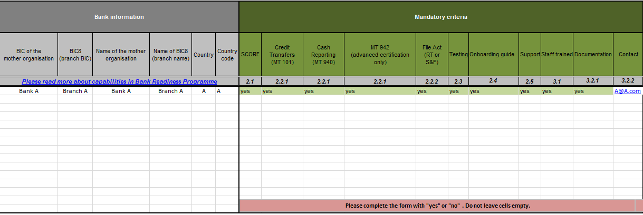
Additional Capabilities (non-mandatory for certification):
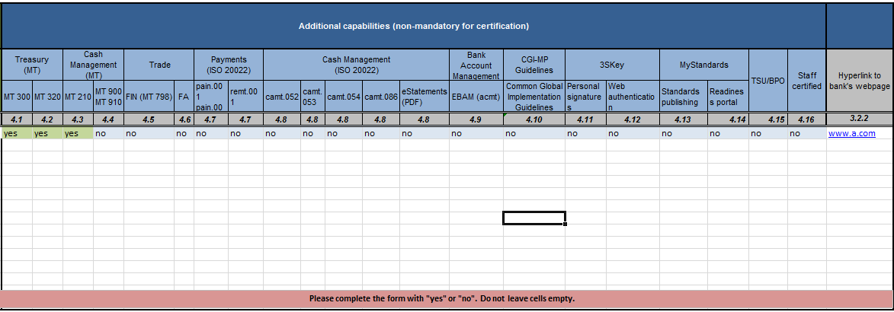
Only when the mandatory section for a certain country is completely green in the tick-list, the bank will be published as ready for that country on the Website. The additional capabilities of the bank will in that case also be shown.
We also allow the non-certified banks to gradually publish their capabilities before fulfilling all of the certification criteria; this allows banking groups to add more granular information at country level, even though “Entry” level is not reached.
Therefore, we will publish the capabilities in the “List of certified banks” document only:
In the column “Certification”, the status will be reflected as “Not Certified”.
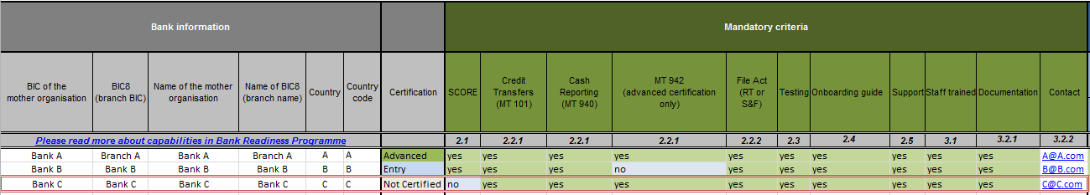

The bank that wants to participate in the certification programme should complete the form available from the bank readiness webpage and send it back to swiftforcorporates@swift.com. Please include “Bank Readiness Certification of “Bank A”” in a subject of your email.
On receipt of the form, SWIFT checks that it is duly completed and that the bank meets the mandatory requirements.
If the bank meets the requirements, SWIFT
- confirms the readiness status to the bank;
- informs the bank about the date when it will be published on the bank readiness webpage;
- provides the bank with the bank readiness label for the current year
A bank certified as ready may use the title “Bank Ready for Corporate Access 201x” and the following label (applicable for the year)

For the purpose and for the duration of their participation in the programme, SWIFT grants the bank the non-exclusive and non-transferable right, without the right to sublicense, to use the title and the label of the programme. This licence becomes effective upon successful certification.

The certified bank may use the title and label to identify and advertise their status. Such advertisements or public statements may not suggest or infer any appreciation or indication by SWIFT as to the quality and the effectiveness of the bank.

If the bank does not meet the requirements, SWIFT notifies the applicant in writing.
- Revision record
Modification | Location | Date
Update of mandatory criteria “hyperlink to bank’s website”: presence of a contact on the bank’s webpage mandatory | Sections 1.3.2 and 3.2.2 | January 2012
New section for application and right to use the title and label | Section 7 | February 2012
Update of ISO 20022 versions of pain and camt | Section 4.6 and 4.7 | May 2012
New optional commercial criteria: Staff certified “SWIFT for Corporates Specialist” | Section 1.3.4 and 5.1 | November 2012
New “Entry” and “Advanced” certification levels; introduced additional SWIFT capabilities as replacement of the Level 2 criteria | Complete document | February 2014
Add readiness capabilities for non-certified SCORE banks. Add the possibility to choose either to provide with a Link to bank's SWIFT webpage or with a Contact detail. | Complete document | July 2015
Add additional capabilities:  - Trade Finance (FA)  - remittance advice (remt.001)  - reporting (camt.086)  - eStatements (PDF)  Rename CGI to CGI-MP | Complete document | January 2016
Contractual information | Section 2.4.2. | May 2016
Add 2 new Optional criteria:  - To be registered as SWIFT gpi member  - SWIFT gpi payments (gCCT) – live | Section 1.2, 4.1 and 4.2 | April 2017
Add 2 new Mandatory criteria:  - Pain.001  - Camt.053 | Section 1.4 and 4 | June 2017

MT942 is only mandatory for the advanced certification level.
pain.001 is only mandatory for the advanced certification level.
camt.053 is only mandatory for the advanced certification level.

